**Q To perform remote desktop sharing within LAN connection using telnet.**

**Explore and try the same with SSH**

**LAN TOPOLOGY**

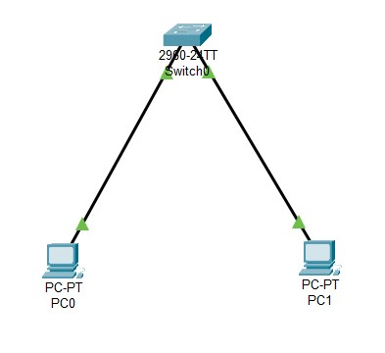

**Checking the connectivity of two PC’s**

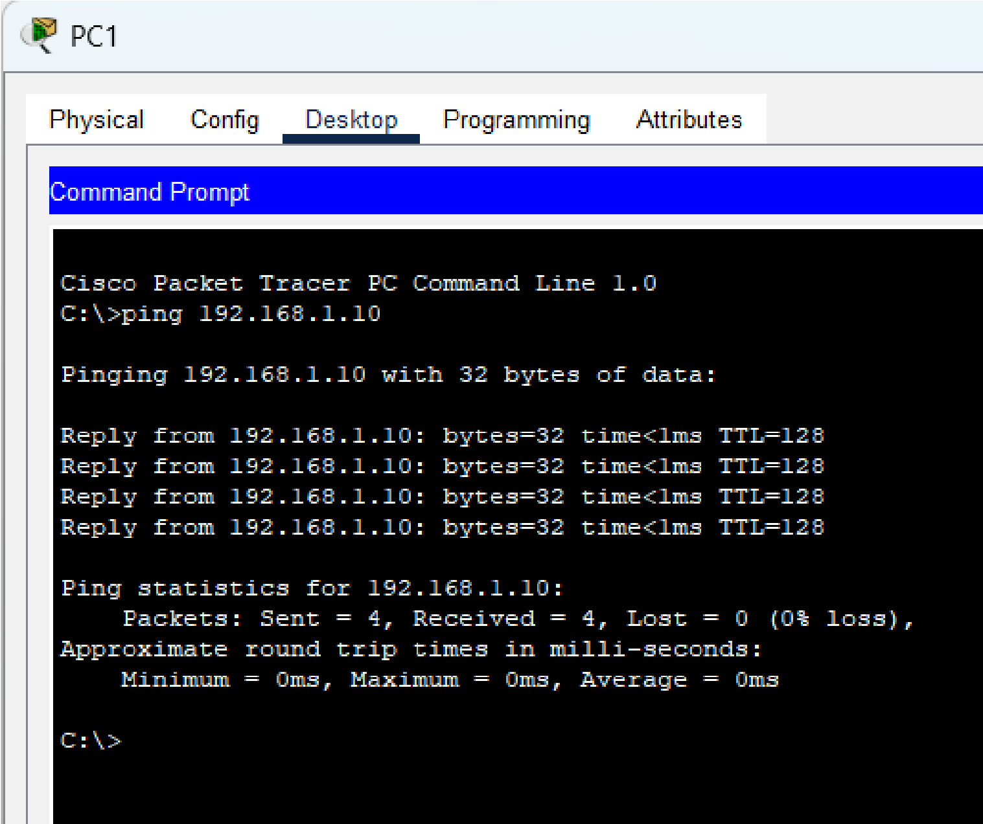

**Configuring the Switch for telnet access**

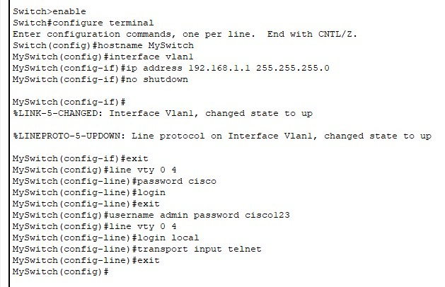

**Final**

